HOW TO EMAIL YOUR CUSTOMERS AN INVITATION:
- Begin a new email message in Outlook or your company’s HTML email service provider (ESP) such as HubSpot, MailChimp, Constant Contact, etc.

- Click on the graphic header below and “copy”. Open the email draft, then “paste” the image into the email editor. Or if creating an HTML eblast, import the desired hero image option. Link the hero image to https://www.bakingexpo.com/register/

- Next, “copy/paste” the body of the email below into the email draft and modify the details as you see fit.

- Double check your booth number against the floor plan for accuracy. The exhibitor discount code is EXH[your booth number]. For example, a company at Booth #1234 would have a 20% off discount code of EXH1234. Exhibitor discount codes activate on March 6, 2025 and cannot be used before this date.

- Once the copy is finalized send the email invite to select recipients.

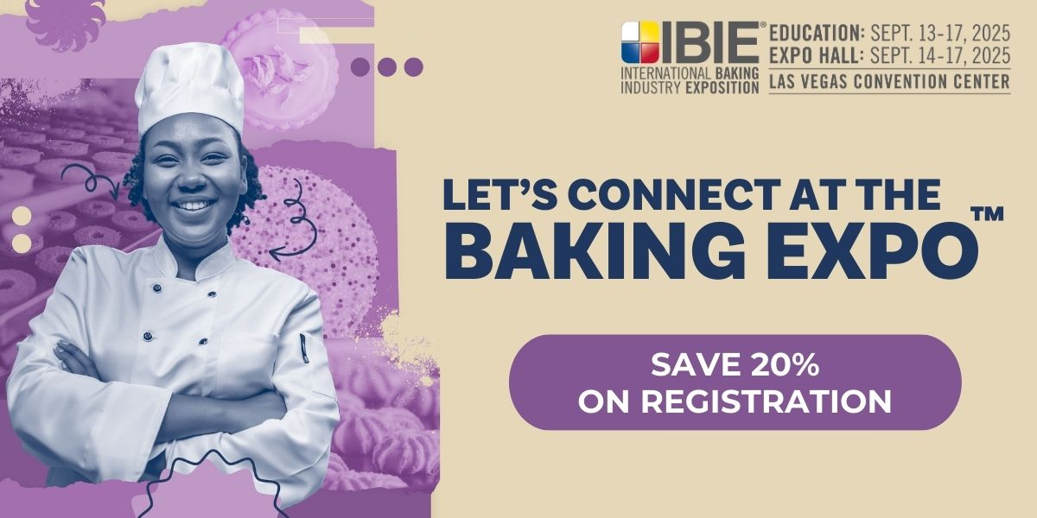

Dear <Insert Customer Name>,

Join us at the International Baking Industry Exposition — the grain-based food industry’s largest, most comprehensive event. <Insert company name> will be located at Booth #XXXX and will be launching new products like <product>, <product>, and <product>. Aside from meeting with us at the expo to X,Y,Z, you might also like to take advantage of IBIE offerings like the complimentary education program and expert demos, unique networking experiences, exciting competitions, prestigious awards and more.

Save 20% on your IBIE 2025 registration when you use our discount code: EXH----

See you in Vegas!

<insert your name/company name and booth number>
Visit BakingExpo.com to register and for additional information.

